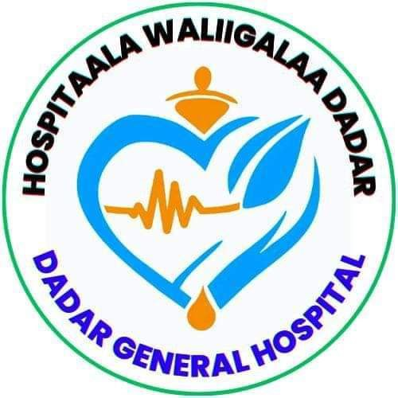

DEDER GENERAL HOSPITAL
Hand Hygiene Compliance Assessment Report

Report period: 4th Quarter of 2017EFY

Conducted By: IPC Committee

June 2017E.C
Deder, Oromia
IPC Committee Member
No | Name | Position | Role
 | Dr. Derese Gosa | Medical Director | Chairperson
 | Hamza Jemal | Head Nurse/Matron | Vice Chairperson
 | Abdi Tofik | Quality & Safety Unit head | Member
 | Addisu Wondimu | OR/Obs/Gyn Head | Member
 | Alamudin Usmail | Laboratory Head | Member
 | Jafer Dine | TB Clinic Head | Member
 | Kalifa Jemal | Surgical Ward head | Member
 | Chala Abdusalam | Pediatrics Head | Member
 | Balisa usmail | Pharmacy Head | Member
 | Obsa Usmail | Finance and Property head | Member
 | Nure Jemal | Maintenance Officer | Member
 | Kadir hasen sali | Laundry Service head | Member
 | Desta Tafesa | Cleaner Head | Member

TABLE OF CONTENTS
Introduction 1
Purpose 2
Scope 2
Methodology. 2
Results 3
1. hand hygiene Compliance Assessment results per Ward/Unit 3
2. According to Professional categories. 12
3. Compliance according to Ward/Unit 13
4. HH Compliance According to Indications 14
5. Deder General Hospital Overall Hand Hygiene compliance rate 15
DISCUSSION 17
Challenges leading to low compliance 18
Recommendations/Interventions. 19

LISTS OF TABLE AND FIGURES
Table 1: Outpatient Department (OPD) 4
Table 2: Medical Ward 5
Table 3: Surgical Ward 6
Table 4: Pediatrics Ward 7
Table 5: Emergency and ICU 8
Table 6: GYNAE/OBSTETRICS WARD 9
Table 7: NICU 10
Table 8: OPERATION THEATRE ROOM (OR) 11
Table 9: Action plan to improve hand hygiene compliance, 2017E.C 20

Figure 1: Deder General Hospital Hand Hygiene Compliance According to Professional categories, June 2017E.C 12
Figure 2: Deder General Hospital Hand Hygiene Compliance according to Ward/Unit, June 2017E.C 13
Figure 3: Deder General Hospital Hand Hygiene Compliance According to Indications, June 2017E.C 14
Figure 4: Deder General Hospital Overall Hand Hygiene compliance rate, June 2017E.C 16

Introduction
Hand hygiene is a fundamental practice in HC settings to prevent HAIs. Despite its importance, hand hygiene compliance among HCWs remains suboptimal. Assessing HH compliance is essential to identify gaps in compliance and design interventions to improve adherence to hand hygiene protocols.
Definition of terms
- Hand Hygiene: practice of cleaning one’s hands to prevent spread of disease-causing bugs. This can be done by Hand Washing with clean water and soap or by Hand rubbing using ABHR.
- Actions: steps and practices undertaken to keep hands clean. In this case HW or HR. However other examples are: drying hands with a clean towel or air dry, not touching your face, mouth or nose with unclean hands, covering your mouth and nose with tissue or elbow when coughing or sneezing, not touching surfaces frequently touched, HW before food eating, or using places of convenience, keep your nails trimmed and clean etc.
- Opportunity: Such a time when one must practice hand Hygiene.
- Indication: Reason for which one must perform Hand Hygiene at a given time. These are derived from the WHO 5 Moments of Hand Hygiene. Before touching a patient, before Clean/Asceptic procedure, After body fluid exposure risk, After touching a patient, After Touching patient surrounding.
- Hand Hygiene compliance: extent to which HCWs, patients and visitors adhere to practicing hand hygiene. Calculated as (Actions/Opportunitiesx100). Reflected as a percentage score.

Purpose
This assessment report provides an overview of HH compliance in Gulu Regional Referral Hospital. This data shall act as a baseline for improvement in compliance henceforth

Scope
All major service units were assessed: OPD, Medical Ward, Surgical Ward, Pediatrics Ward, Emergency & ICU, Gyn/Obs Ward, NICU, and Operating Theatre (OR).

Methodology.
- Tool: MoH/WHO-adapted Hand Hygiene Observation Form
- Opportunities & sessions: Two observation sessions were conducted per unit over two weeks.
- Compliance definition: Actions/Opportunities × 100 (actions include hand washing with soap and water, or hand rubbing with ABHR).
- Target: ≥80% per unit; ≥90% hospital-wide
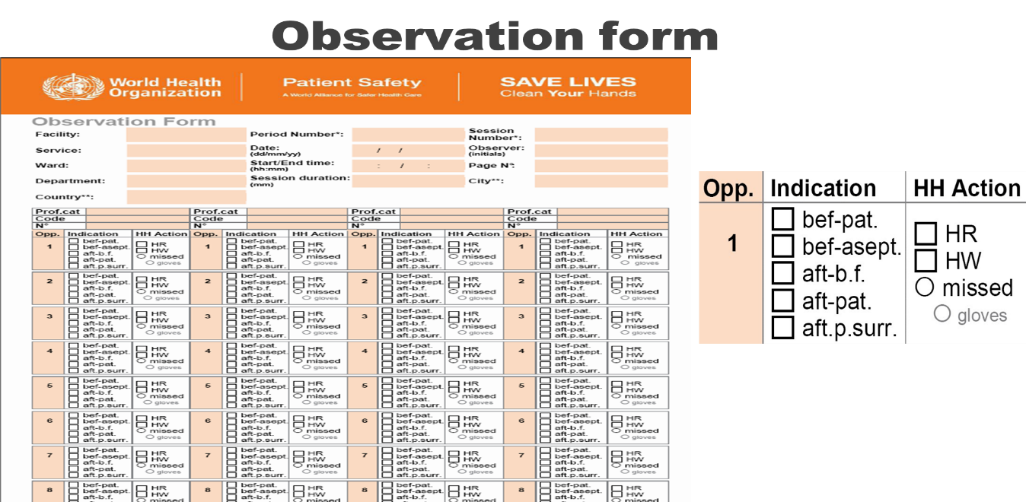

Results

hand hygiene Compliance Assessment results per Ward/Unit
The hand hygiene compliance assessment across Deder General Hospital's wards revealed significant variations. The Emergency and ICU unit achieved the highest compliance rate at 95%, driven by strong performance from nurses (97%) and auxiliary staff (92%). Conversely, the Medical Ward recorded the lowest compliance at 83%, with auxiliary staff lagging at 75%. Most units exceeded the 80% target, including Pediatrics (92%), NICU (94%), and Surgical Ward (88%). However, persistent gaps in auxiliary staff compliance were observed in multiple wards, such as OPD (75%) and Gyn/Obs (82%), indicating systemic challenges.

Figure 2: Deder General Hospital Hand Hygiene Compliance according to Ward/Unit, June 2017E.C

- Outpatient Department (OPD)
Table 1: Outpatient Department (OPD)
- Opportunities: 100
- Actions: 88
Professional category | HW | HR | Total actions | Compliance
Medical Doctors | 10 | 18 | 28 | 93%
Nurses | 8 | 22 | 30 | 94%
Auxiliary staff | 9 | 21 | 30 | 75%
Total number of hand hygiene opportunities performed
Hand Washing : 27 Hand rubbing : 61
Hand Hygiene Compliance of the ward: $\frac{Total actions}{Total opportunities}*100=\frac{88}{100}*100=88\%$
- Medical Ward

Table 2: Medical Ward
- Opportunities: 128
- Actions: 106
Professional category | HW | HR | Total actions | Compliance
Medical Doctors | 12 | 16 | 28 | 88%
Nurses | 14 | 22 | 36 | 90%
Auxiliary staff | 18 | 24 | 42 | 75%
Total number of hand hygiene opportunities performed
Hand Washing : 44 Hand rubbing : 62
Hand Hygiene Compliance of the ward: $\frac{Total actions}{Total opportunities}*100=\frac{106}{128}*100=83\%$£

- Surgical Ward
- Opportunities: 100
- Actions: 88
Table 3: Surgical Ward
Professional category | HW | HR | Total actions | Compliance
Medical Doctors | 14 | 18 | 32 | 91%
Nurses | 15 | 21 | 36 | 92%
Auxiliary staff | 14 | 23 | 37 | 79%

Total number of hand hygiene opportunities performed
Hand Washing : 27 Hand rubbing : 61
Hand Hygiene Compliance of the ward: $\frac{Total actions}{Total opportunities}*100=\frac{88}{100}*100=88\%$
- Pediatrics Ward
- Opportunities: 96
- Actions: 88
Table 4: Pediatrics Ward
Professional category | HW | HR | Total actions | Compliance
Medical Doctors | 9 | 12 | 21 | 88%
Nurses | 16 | 18 | 34 | 94%
Auxiliary staff | 15 | 18 | 33 | 89%

Total number of hand hygiene opportunities performed
Hand Washing : 40 Hand rubbing : 48
Hand Hygiene Compliance of the ward: $\frac{Total actions}{Total opportunities}*100=\frac{88}{96}*100=92\%$

- Emergency and ICU
- . Opportunities: 128
- Actions: 88
Table 5: Emergency and ICU
Professional category | HW | HR | Total actions | Compliance
Medical Doctors | 18 | 16 | 34 | 91%
Nurses | 26 | 24 | 50 | 97%
Auxiliary staff | 20 | 18 | 38 | 92%

Total number of hand hygiene opportunities performed
Hand Washing : 64 Hand rubbing : 58
Hand Hygiene Compliance of the ward: $\frac{Total actions}{Total opportunities}*100=\frac{122}{128}*100=95\%$

- GYNAE/OBSTETRICS WARD
- Opportunities: 60
- Actions: 53
Table 6: GYNAE/OBSTETRICS WARD
Professional category | HW | HR | Total actions | Compliance
Medical Doctors | 6 | 7 | 13 | 93%
Midwives | 8 | 9 | 17 | 89%
Auxiliary staff | 10 | 13 | 23 | 82%

Total number of hand hygiene opportunities performed
Hand Washing: 24 Hand rubbing: 29
Hand Hygiene Compliance of the ward: $\frac{Total actions}{Total opportunities}*100=\frac{53}{60}*100=88\%$

- NICU
- Opportunities: 128
- Actions: 120
Table 7: NICU
Professional category | HW | HR | Total actions | Compliance
Medical Doctors | 18 | 10 | 28 | 88%
Nurses | 28 | 10 | 38 | 95%
Auxiliary staff | 30 | 24 | 54 | 96%
Total number of hand hygiene opportunities performed
Hand Washing : 76 Hand rubbing : 44
Hand Hygiene Compliance of the ward: $\frac{Total actions}{Total opportunities}*100=\frac{120}{128}*100=94\%$

- OPERATION THEATRE ROOM (OR)
- Opportunities: 29
- Actions: 28
Table 8: OPERATION THEATRE ROOM (OR)
Professional category | HW | HR | Total actions | Compliance
Medical Doctors | 6 | 6 | 12 | 100%
Nurses | 7 | 5 | 12 | 100%
Auxiliary staff | 2 | 2 | 4 | 80%
Total number of hand hygiene opportunities performed
Hand Washing : 15 Hand rubbing : 13
Hand Hygiene Compliance of the ward: $\frac{Total actions}{Total opportunities}*100=\frac{28}{29}*100=88\%$

According to Professional categories.
Nurses consistently demonstrated high compliance, leading in 6 of 8 units (e.g., 97% in Emergency/ICU, 95% in NICU). Medical doctors showed robust adherence in critical areas like the OR (100%) but varied elsewhere (88% in Pediatrics). Auxiliary staff had the widest fluctuations—exceeding expectations in NICU (96%) but underperforming in OPD (75%) and OR (80%). Notably, in NICU, auxiliary staff outperformed doctors (88%), suggesting unit-specific dynamics influence compliance.
Figure 1: Deder General Hospital Hand Hygiene Compliance According to Professional categories, June 2017E.C

HH Compliance According to Indications
Hand hygiene compliance at Deder General Hospital varied significantly across the WHO's "Five Moments," with adherence improving progressively in later stages of patient interaction. Compliance was lowest before high-risk actions—85% before patient contact and 88% before aseptic procedures—indicating gaps in preemptive hygiene. In contrast, compliance surged after exposure events: 92% after body fluid exposure, 93% after direct patient contact, and peaked at 97% after touching patient surroundings. This pattern suggests staff prioritize reactive hygiene (post-contamination) over proactive measures (pre-exposure), potentially increasing infection transmission risks during initial patient interactions.

Figure 3: Deder General Hospital Hand Hygiene Compliance According to Indications, June 2017E.C

Deder General Hospital Overall Hand Hygiene compliance rate
This was calculated by adding the cumulative ward/unit actions against cumulative corresponding opportunities.

Category | OPD | MW | SW | PW | ICU & Eme | GNOBS | NICU | OR | TOTAL
AC | 88 | 106 | 88 | 88 | 88 | 53 | 120 | 28 | 710
OPP | 100 | 128 | 100 | 96 | 128 | 60 | 128 | 29 | 789

- Total action = 710
- Cumulative opportunities observed = 789
- DGH HH compliance: $\frac{Total actions}{Total opportunities}*100=\frac{710}{789}*100=90\%$

The overall hand hygiene (HH) performance at Deder General Hospital during the 1st Quarter of 2017 E.C. demonstrated commendable progress, achieving a cumulative compliance rate of 90% (710 actions out of 789 opportunities). Most wards surpassed the institutional benchmark of 80%, with particularly strong performance in the Emergency & ICU (95%), NICU (94%), and Pediatrics (92%). Notably, the Operation Theatre Room recorded 100% compliance by both doctors and nurses, underscoring the critical role of procedural discipline in sterile environments. However, some gaps persisted, especially among auxiliary staff in several units like OPD (75%) and Gyn/Obs Ward (82%), indicating the need for targeted interventions to ensure uniform adherence across all staff categories and departments.

Figure 4: Deder General Hospital Overall Hand Hygiene compliance rate, June 2017E.C

DISCUSSION
The hand hygiene compliance assessment at Deder General Hospital for the 1st Quarter of 2017 E.C. revealed a generally positive trend, with most departments achieving or exceeding the 80% compliance target. Units such as the Emergency & ICU (95%), NICU (94%), and Pediatrics Ward (92%) demonstrated exemplary performance, reflecting strong adherence to infection prevention protocols. These high-performing departments also showed consistent compliance across all professional categories, particularly among nurses who played a central role in maintaining standards. The Operation Theatre Room achieved a 100% compliance rate among medical doctors and nurses, highlighting the impact of high-risk awareness and procedural rigor on behavior.
Despite the encouraging overall performance, the results also underscored persistent disparities, especially among auxiliary staff. For example, OPD (75%) and OR (80%) had the lowest auxiliary compliance, signaling possible gaps in training, supervision, or perceived importance of hand hygiene among non-clinical staff. Additionally, compliance varied across the WHO’s "Five Moments of Hand Hygiene," with lower adherence before patient contact (85%) and before aseptic procedures (88%), compared to higher rates after exposure moments (above 90%). This reactive pattern suggests that staff may prioritize hygiene in response to visible contamination risks, rather than proactively preventing transmission—a mindset that could compromise patient safety, especially in vulnerable units.
These findings highlight the need for reinforcing a culture of proactive infection prevention, targeted education tailored to auxiliary staff, and greater emphasis on pre-contact hygiene. Structured mentoring, routine feedback, and inclusion of all cadres in continuous quality improvement initiatives can help close these gaps and sustain high performance hospital-wide.

Recommendations/Intervention
- Strengthen Auxiliary Staff Engagement and Training:
- Enhance Pre-Contact Compliance Awareness:
- Implement Continuous Onsite Mentorship and Supervision:
- Institutionalize Regular Audits and Feedback Loops:
- Ensure Consistent Availability of Supplies:
- Integrate Hand Hygiene in Morning Briefings and Clinical Rounds:

Table 9: Action plan to improve hand hygiene compliance, 2017E.C
Key Gap Identified | Action to be taken | Responsible body | Time Frame
Low compliance among auxiliary staff | Provide focused training and on-the-job mentorship for auxiliary workers | IPC Focal Person, Department Heads | July –September 2018E.C
Poor hand hygiene before patient contact and aseptic tasks | Reinforce awareness on the "5 Moments" through posters and reminders | IPC Committee, Health Education Unit | Continuous
Limited use of audit data for action | Conduct quarterly HH audits and feedback meetings with all units | IPC Committee, Quality Office | Quarterly
Weak integration into daily routines | Include HH reminders in daily staff briefings and ward rounds | Department Heads, Team Leaders | Immediate and ongoing
Low compliance among auxiliary staff | Provide focused training and on-the-job mentorship for auxiliary workers | IPC Focal Person, Department Heads | July –September 2018E.C
Poor hand hygiene before patient contact and aseptic tasks | Reinforce awareness on the "5 Moments" through posters and reminders | IPC Committee, Health Education Unit | Continuous

